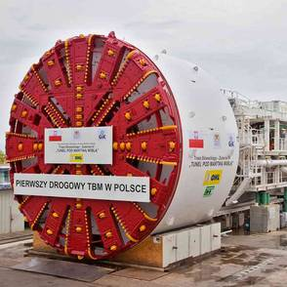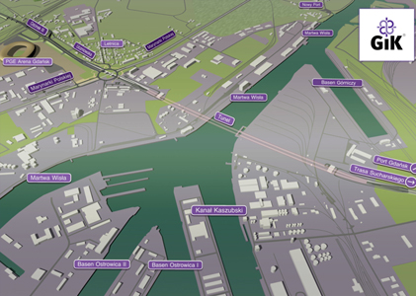Tunnel Gdansk

an existing motorway bridge and addition of a new bridge

|  |  |
| --- | --- |
| General Data:  Herrenknecht TBM, 12,56 m  Map of location | |
| **Project:** | Road tunnel under the Vistula in Gdansk |
| **Client:** | **OHL** Obrascon Huarte Lain S.A. |
| **Delivery period:** | 2013 - 2014 |
| **Scope of work:** | The "Słowacki route" links the "Lech Wałęsa Airport" with the Gdansk deep-water seaport. Road passes under the Vistula with a twin tube tunnel with a total length of 1.4 kilometers  2 TBM-driven tunnels, length: 1,1 km each, external diameter 12,2 m, 2090 rings of 6+1 segments |
| Sealing method: | Maximum hydraulic pressure 3,5 bars  Test pressure 7 bars at combination of 5 mm gap and 10 mm offset  TunnelFlex 44 S, Rubber gaskets with 90° Soft corners |
|  | TS 44x12 (9) h=20 E 131 Gdansk |
| **Additional information:** | ES Rubber Ltd. | Kibbutz Ein Shemer | M.P. Hefer 38816, Israel | +972.4.637.1037 | [export@esrubber.com](mailto:export@esrubber.com) | www.esrubber.com  Dr. Werner Grabe mobile +49 174 6884223 |